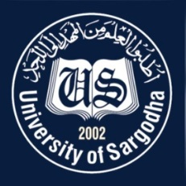  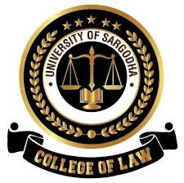 | Faculty Positions on Visiting Basis
College of Law
University of Sargodha
Applications for the following positions are invited from Pakistani nationals for Spring semester 2021.
Teaching Faculty

Sr.# | Positions | No. of Posts | Nature of Post | Eligibility Criteria
1. | Visiting Lecturers | (04)* | Visiting Faculty  (Open merit, for Spring semester 2021). | Qualification:-  - LLB having 05 Years standing as Advocate of High Court (Criteria settled by Supreme Court in Constitution Petition No. 134/2012 dated 13-12-2018).  - Preference will be given to LLM.
NOTE |  |  | General Information
- As per university policy, the College of Law reserves the right not to consider any application or fill any post without giving any reason.
- Candidates are required to submit complete latest C.V, License of High Court, two latest Passport Size Pictures and attested copies of all testimonial documents along with duly filled application form in the Admin Office of College of Law, University of Sargodha.
- Prescribed application form may be downloaded from university website
(https://www .uos.edu .pk/adminForms)
- Applications complete in all respects should reach the College of Law on or before 12-02-2021 (Friday).
- Only short listed candidates will be called for interview. List of short-listed candidates will be displayed on 15-02-2021 (Monday).
- Interview of the short-listed candidates will be conducted on 16-02-2021 (Tuesday) at10:00A.M in the office of Incharge Principal, College of Law, University of Sargodha.
- The applicants having provisional transcript will not be eligible for the visiting faculty
- Applications received after due date will not be entertained.
- Candidates with relevant experience will be preferred.
- Seats can be increased or decreased according to the availability of Credit Hours.
- Applications should be addressed to Incharge Principal, College of Law, University of Sargodha.
- Online applications will not be accepted.

* Number of Posts may be increased or decreased according to the availibility of Credit Hours

Incharge Principal
College of Law,
University of Sargodha

